St. Paul’s Episcopal Church
In the Episcopal Diocese of East Carolina

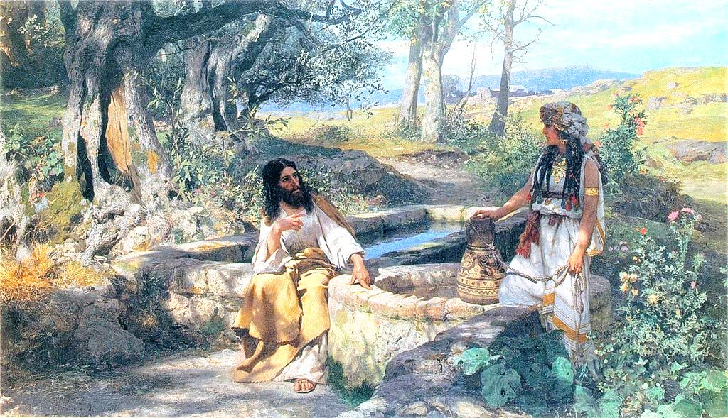
Henryk Siemyradzki (Polish, 1843-1902) Christ and the Samaritan Woman, 1890.
Oil on canvas. Lviv National Art Gallery.

Sunday, March 15, 2020
The Third Sunday in Lent
To Know Christ and to make Christ known…
St. Paul’s invites all people to the Christian Way of unity with God and neighbor
through a welcoming environment of worship and ministry
Please enter the church in silence so that all may have quiet time to prepare hearts and minds for worship.
The Holy Eucharist
Voluntary Andante religioso (from Sonata IV) Felix Mendelssohn Introit God So Loved the World (from The Crucifixion) John Stainer
God so loved the world that he gave his only begotten Son, that whoso believeth in him, should not perish, but have everlasting life. God sent not his Son into the world to condemn the world, but that the world through him, might be saved.
The Word of God
Processional Guide me, O thou great Jehovah Hymnal 690
Celebrant Bless the Lord who forgives all our sins.
People His mercy endures for ever.
The Confession BCP 351
Celebrant Jesus said, “The first commandment is this: Hear, O Israel: The Lord our God is the only Lord. Love the Lord your God with all your heart, with all your soul, with all your mind, and with all your strength. The second is this: Love your neighbor as yourself. There is no other commandment greater than these.” Mark 12:29-31
Celebrant: Let us confess our sins against God and our neighbor.
Silence may be kept.
Minister and People
Most merciful God, we confess that we have sinned against you
in thought, word, and deed, by what we have done,
and by what we have left undone.
We have not loved you with our whole heart;
we have not loved our neighbors as ourselves.
We are truly sorry and we humbly repent.
For the sake of your Son Jesus Christ, have mercy on us and forgive us;
that we may delight in your will, and walk in your ways,
to the glory of your Name. Amen.
The Celebrant stands and says
Almighty God have mercy on you, forgive you all your sins through our Lord Jesus Christ, strengthen you in all goodness, and by the power of the Holy Spirit keep you in eternal life. Amen.
Trisagion Hymnal S100
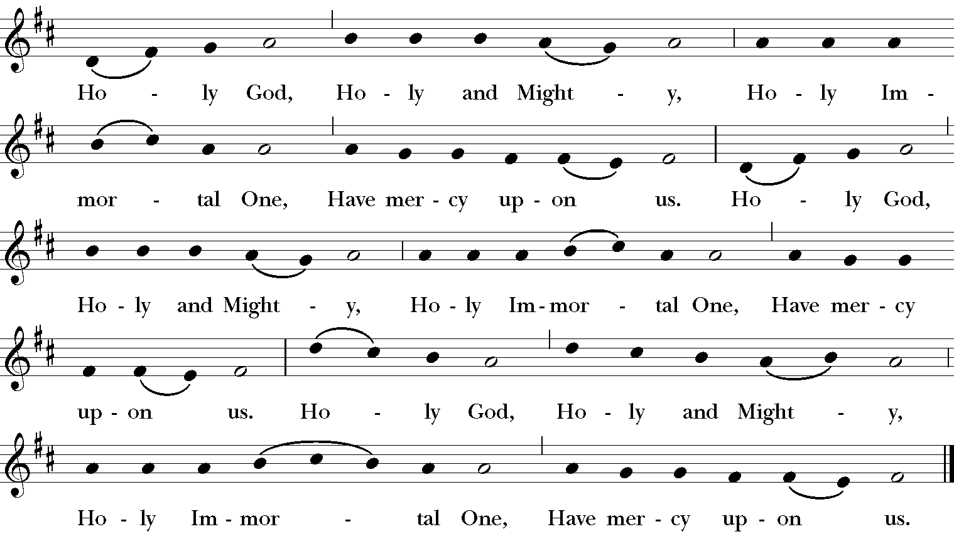
From New Plainsong; David Hurd (b. 1950)

Celebrant The Lord be with you.
People: And also with you.
Celebrant: Let us pray.
The Collect of the Day BCP 218
Almighty God, you know that we have no power in ourselves to help ourselves: Keep us both outwardly in our bodies and inwardly in our souls, that we may be defended from all adversities which may happen to the body, and from all evil thoughts which may assault and hurt the soul; through Jesus Christ our Lord, who lives and reigns with you and the Holy Spirit, one God, for ever and ever. Amen. (The people may be seated.)
A Reading from Exodus (127:1-7)
From the wilderness of Sin the whole congregation of the Israelites journeyed by stages, as the Lord commanded. They camped at Rephidim, but there was no water for the people to drink. The people quarreled with Moses, and said, “Give us water to drink.” Moses said to them, “Why do you quarrel with me? Why do you test the Lord?” But the people thirsted there for water; and the people complained against Moses and said, “Why did you bring us out of Egypt, to kill us and our children and livestock with thirst?” So Moses cried out to the Lord, “What shall I do with this people? They are almost ready to stone me.” The Lord said to Moses, “Go on ahead of the people, and take some of the elders of Israel with you; take in your hand the staff with which you struck the Nile, and go. I will be standing there in front of you on the rock at Horeb. Strike the rock, and water will come out of it, so that the people may drink.” Moses did so, in the sight of the elders of Israel. He called the place Massah and Meribah, because the Israelites quarreled and tested the Lord, saying, “Is the Lord among us or not?”
Reader The Word of the Lord.
People Thanks be to God. (Silence for reflection upon the reading.)
Psalm 95 BCP 624

¹Come, let us sing to the Lord; *
let us shout for joy to the Rock of our salvation.
²Let us come before his presence with thanksgiving *
and raise a loud shout to him with psalms.
³For the Lord is a great God, *
and a great King above all gods.
⁴In his hand are the caverns of the earth, *
and the heights of the hills are his also.
⁵The sea is his, for he made it, *
and his hands have molded the dry land.
⁶Come, let us bow down, and bend the knee, *
and kneel before the Lord our Maker.
⁷For he is our God,
and we are the people of his pasture and the sheep of his hand. *
Oh, that today you would hearken to his voice!
⁸Harden not your hearts, as your forebears did in the wilderness, *
at Meribah, and on that day at Massah, when they tempted me.
⁹They put me to the test, *
though they had seen my works.
¹⁰Forty years long I detested that generation and said, *
“This people are wayward in their hearts; they do not know my ways.”
¹¹So I swore in my wrath, *
“They shall not enter into my rest.”
A Reading from Romans (5:1-11)
Since we are justified by faith, we have peace with God through our Lord Jesus Christ, through whom we have obtained access to this grace in which we stand; and we boast in our hope of sharing the glory of God. And not only that, but we also boast in our sufferings, knowing that suffering produces endurance, and endurance produces character, and character produces hope, and hope does not disappoint us, because God’s love has been poured into our hearts through the Holy Spirit that has been given to us.
For while we were still weak, at the right time Christ died for the ungodly. Indeed, rarely will anyone die for a righteous person—though perhaps for a good person someone might actually dare to die. But God proves his love for us in that while we still were sinners Christ died for us. Much more surely then, now that we have been justified by his blood, will we be saved through him from the wrath of God. For if while we were enemies, we were reconciled to God through the death of his Son, much more surely, having been reconciled, will we be saved by his life. But more than that, we even boast in God through our Lord Jesus Christ, through whom we have now received reconciliation.
Reader The Word of the Lord.
People Thanks be to God.
Hymn to Announce the Gospel Shepherd of souls, refresh and bless Hymnal 343
The Holy Gospel of our Lord Jesus Christ According to John (4:5-42)
People: Glory to you, Lord Christ.
[Jesus] came to a Samaritan city called Sychar, near the plot of ground that Jacob had given to his son Joseph. Jacob’s well was there, and Jesus, tired out by his journey, was sitting by the well. It was about noon.
A Samaritan woman came to draw water, and Jesus said to her, “Give me a drink.” (His disciples had gone to the city to buy food.) The Samaritan woman said to him, “How is it that you, a Jew, ask a drink of me, a woman of Samaria?” (Jews do not share things in common with Samaritans.) Jesus answered her, “If you knew the gift of God, and who it is that is saying to you, ‘Give me a drink,’ you would have asked him, and he would have given you living water.” The woman said to him, “Sir, you have no bucket, and the well is deep. Where do you get that living water? Are you greater than our ancestor Jacob, who gave us the well, and with his sons and his flocks drank from it?” Jesus said to her, “Everyone who drinks of this water will be thirsty again, but those who drink of the water that I will give them will never be thirsty. The water that I will give will become in them a spring of water gushing up to eternal life.” The woman said to him, “Sir, give me this water, so that I may never be thirsty or have to keep coming here to draw water.”
Jesus said to her, “Go, call your husband, and come back.” The woman answered him, “I have no husband.” Jesus said to her, “You are right in saying, ‘I have no husband’; for you have had five husbands, and the one you have now is not your husband. What you have said is true!” The woman said to him, “Sir, I see that you are a prophet. Our ancestors worshiped on this mountain, but you say that the place where people must worship is in Jerusalem.” Jesus said to her, “Woman, believe me, the hour is coming when you will worship the Father neither on this mountain nor in Jerusalem. You worship what you do not know; we worship what we know, for salvation is from the Jews. But the hour is coming, and is now here, when the true worshipers will worship the Father in spirit and truth, for the Father seeks such as these to worship him. God is spirit, and those who worship him must worship in spirit and truth.” The woman said to him, “I know that Messiah is coming” (who is called Christ). “When he comes, he will proclaim all things to us.” Jesus said to her, “I am he, the one who is speaking to you.”
Just then his disciples came. They were astonished that he was speaking with a woman, but no one said, “What do you want?” or, “Why are you speaking with her?” Then the woman left her water jar and went back to the city. She said to the people, “Come and see a man who told me everything I have ever done! He cannot be the Messiah, can he?” They left the city and were on their way to him.
Meanwhile the disciples were urging him, “Rabbi, eat something.” But he said to them, “I have food to eat that you do not know about.” So the disciples said to one another, “Surely no one has brought him something to eat?” Jesus said to them, “My food is to do the will of him who sent me and to complete his work. Do you not say, ‘Four months more, then comes the harvest’? But I tell you, look around you, and see how the fields are ripe for harvesting. The reaper is already receiving wages and is gathering fruit for eternal life, so that sower and reaper may rejoice together. For here the saying holds true, ‘One sows and another reaps.’ I sent you to reap that for which you did not labor. Others have labored, and you have entered into their labor.”
Many Samaritans from that city believed in him because of the woman’s testimony, “He told me everything I have ever done.” So when the Samaritans came to him, they asked him to stay with them; and he stayed there two days. And many more believed because of his word. They said to the woman, “It is no longer because of what you said that we believe, for we have heard for ourselves, and we know that this is truly the Savior of the world.”
Deacon: The Gospel of the Lord.
People: Praise to you, Lord Christ.
The Sermon The Rev. Adam Pierce
The Nicene Creed BCP 358
We believe in one God, the Father, the Almighty, maker of heaven and earth, of all that is, seen and unseen.
We believe in one Lord, Jesus Christ, the only Son of God, eternally begotten of the Father, God from God, Light from Light, true God from true God, begotten, not made, of one Being with the Father. Through him all things were made. For us and for our salvation he came down from heaven; by the power of the Holy Spirit he became incarnate from the Virgin Mary, and was made man. For our sake he was crucified under Pontius Pilate; he suffered death and was buried. On the third day he rose again in accordance with the Scriptures; he ascended into heaven and is seated at the right hand of the Father. He will come again in glory to judge the living and the dead, and his kingdom will have no end.
We believe in the Holy Spirit, the Lord, the giver of life, who proceeds from the Father and the Son. With the Father and the Son he is worshiped and glorified. He has spoken through the Prophets. We believe in one holy catholic and apostolic Church. We acknowledge one baptism for the forgiveness of sins. We look for the resurrection of the dead, and the life of the world to come. Amen.
The Prayers of the People (Form V) BCP 389
All remain standing.
In peace, let us pray to the Lord, saying, “Lord, have mercy”
For the holy Church of God, that it may be filled with truth and love, and be found without fault at the day of your coming, we pray to you, O Lord.
Here and after every petition the People respond
Lord, have mercy.
For Michael our Presiding Bishop, Rob our own bishop, Ray our interim rector, Adam our assistant rector, Richard our priest associate; for Emmanuel, Farmville and Church of the Good Shepherd, Fayetteville; for all bishops and other ministers, and for all the holy people of God, we pray to you, O Lord.
For all who fear God and believe in you, Lord Christ, that our divisions may cease, and that all may be one as you and the Father are one, we pray to you, O Lord.
For the mission of the Church, that in faithful witness it may preach the Gospel to the ends of the earth, we pray to you, O Lord.
For the peace of the world, that a spirit of respect and forbearance may grow among nations and peoples, we pray to you, O Lord.
For those in positions of public trust, especially Donald our president and Roy our governor, that they may serve justice, and promote the dignity and freedom of every person, we pray to you, O Lord.
For the poor, the persecuted, the sick, and all who suffer; for refugees, prisoners, and all who are in danger; that they may be relieved and protected, we pray to you, O Lord.
For this congregation, that we may be delivered from hardness of heart, and show forth your glory in all that we do, we pray to you, O Lord.
For John, Joyce, Herb, David, Kathy, Jere, William, Bill, Sally, JoAnn, Ralph and Pat, and those friends of the Parish listed in the bulletin; and for
all who have commended themselves to our prayers; for our families, friends, and neighbors; that being freed from anxiety, they may live in joy, peace, and health, we pray to you, O Lord.
For all who have died in the communion of your Church, and those whose faith is known to you alone, that, with all the saints, they may have rest in that place where there is no pain or grief, but life eternal, we pray to you, O Lord.
Rejoicing in the fellowship of all the saints, let us commend ourselves, and one another, and all our life to Christ our God.
To you, O Lord our God.
Silence
The Celebrant adds a concluding Collect, or the following Doxology
For yours is the majesty, O Father, Son, and Holy Spirit; yours is the kingdom and the power and the glory, now and for ever. Amen.
The Peace
Celebrant The peace of the Lord be always with you.
People And also with you.
The Holy Communion
Choral Anthem Greater Love Hath No Man John Ireland
Kori Meyer, soprano; Alex Gazda, bass
Many waters cannot quench love, neither can the floods drown it. Love is strong as death. Greater love hath no man than this, that a man lay down his life for his friends. Who his own self bare our sins in his own body on the tree, that we being dead to sins, should live unto righteousness. Ye are wash’d, ye are sanctified, ye are justified, in the name of the Lord Jesus; ye are a chosen generation, a royal priesthood, a holy nation. That ye should shew forth the praises of him who hath call’d you out of darkness, into his marvelous light. I beseech you, brethren, by the mercies of God, that ye present your bodies, a living sacrifice, holy, acceptable unto God, which is your reasonable service.
The people stand.
Congregational response From all that dwell below the skies Hymnal 380
Words: Isaac Watts (1674–1748), para. of Psalm 117. St. 3, Thomas Ken (1637–1711)
Music: Old 100th, melody from Pseaumes octante trois de David, 1551, alt.; harm. after Louis Bourgeois (1510?–1561?)

The Great Thanksgiving Eucharistic Prayer A BCP 361
Celebrant | The Lord be with you.
People | And also with you.
Celebrant | Lift up your hearts.
People | We lift them to the Lord.
Celebrant | Let us give thanks to the Lord our God.
People | It is right to give God thanks and praise.
It is right, and a good and joyful thing, always and everywhere to give thanks to you, Almighty God, Creator of heaven and earth.

You bid your faithful people cleanse their hearts, and prepare with joy for the Paschal feast; that, fervent in prayer and in works of mercy, and renewed by your Word and Sacraments, they may come to the fullness of grace which you have prepared for those who love you.

Therefore we praise you, joining our voices with Angels and Archangels and with all the company of heaven, who for ever sing this hymn to proclaim the glory of your Name:
Celebrant and People
Sanctus S124
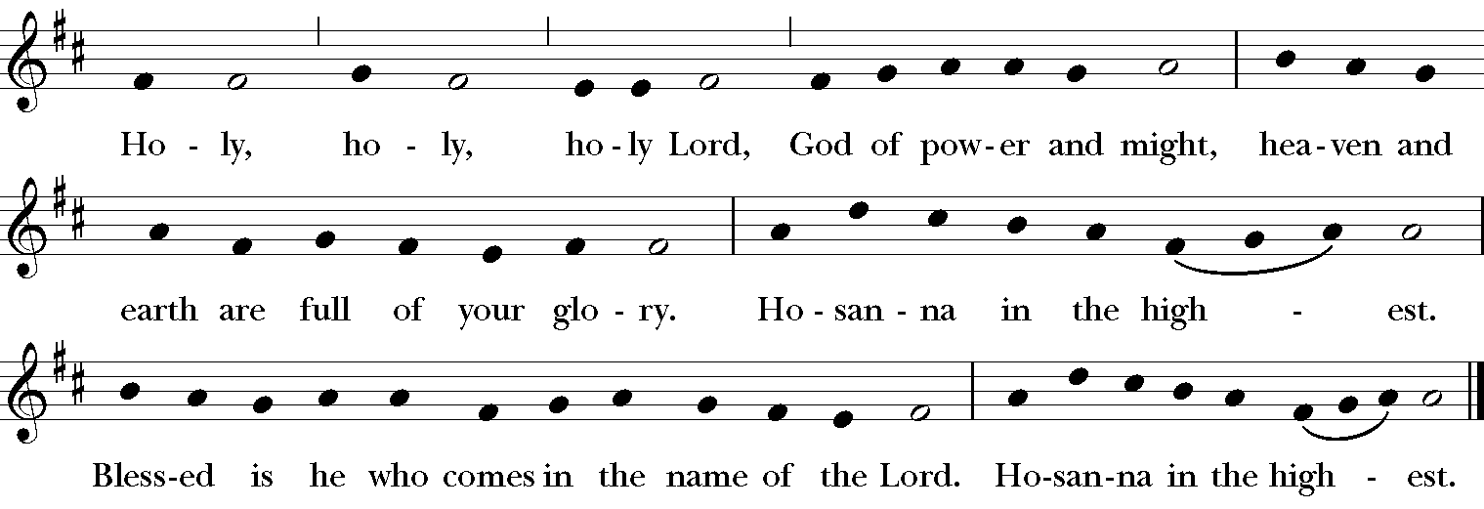
From New Plainsong; David Hurd (b. 1950)

Then the Celebrant continues BCP 362-363
Holy and gracious God: In your infinite love you made us for yourself; and, when we had fallen into sin and become subject to evil and death, you, in your mercy, sent Jesus Christ, your only and eternal Son, to share our human nature, to live and die as one of us, to reconcile us to you, the God and maker of all.
He stretched out his arms upon the cross, and offered himself in obedience to your will, a perfect sacrifice for the whole world.
On the night he was handed over to suffering and death, our Lord Jesus Christ took bread; and when he had given thanks to you, he broke it, and gave it to his disciples, and said, “Take, eat: This is my Body, which is given for you. Do this for the remembrance of me.”
After supper he took the cup of wine; and when he had given thanks, he gave it to them, and said, “Drink this, all of you: This is my Blood of the new Covenant, which is shed for you and for many for the forgiveness of sins. Whenever you drink it, do this for the remembrance of me.”
Therefore we proclaim the mystery of faith:
Celebrant and People
Christ has died.
Christ is risen.
Christ will come again.
The Celebrant continues
We celebrate the memorial of our redemption, Almighty God, in this sacrifice of praise and thanksgiving. Recalling his death, resurrection, and ascension, we offer you these gifts.
Sanctify them by your Holy Spirit to be for your people the Body and Blood of your Son, the holy food and drink of new and unending life in him. Sanctify us also that we may faithfully receive this holy Sacrament, and serve you in unity, constancy, and peace; and at the last day bring us with all your saints into the joy of your eternal kingdom.
All this we ask through your Son Jesus Christ. By him, and with him, and in him, in the unity of the Holy Spirit all honor and glory is yours, Almighty God, now and for ever. AMEN.
The Lord’s Prayer BCP 336
The Breaking of the Bread A period of silence is kept.
Fraction Anthem S 161
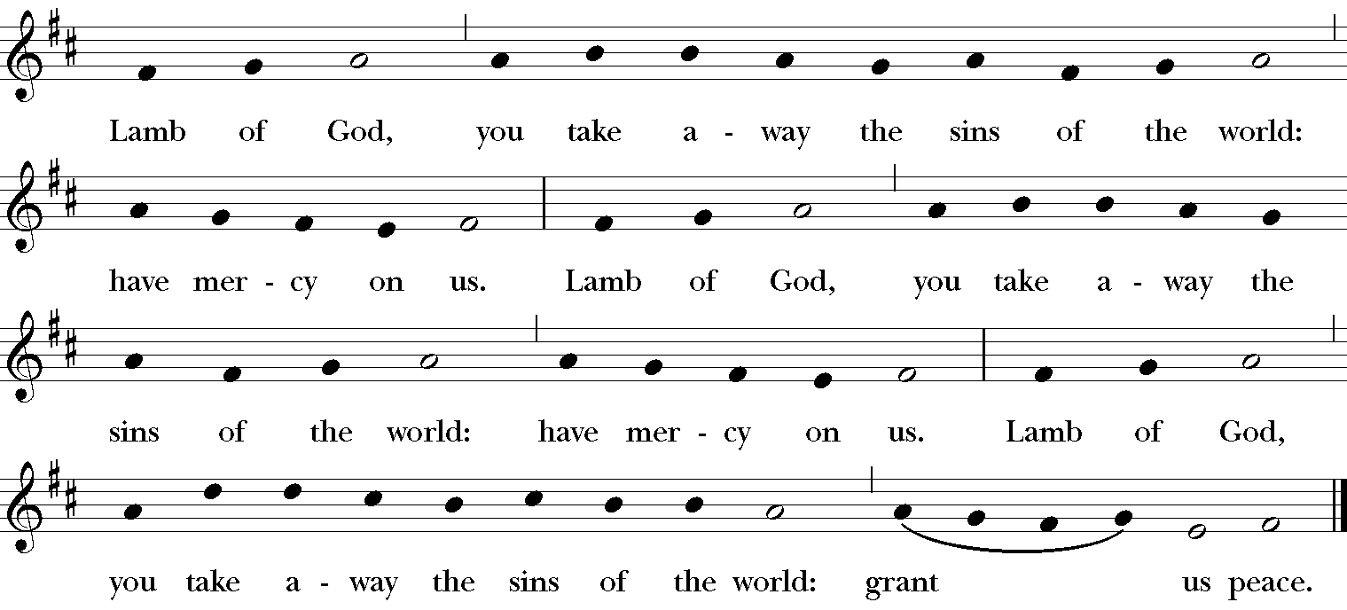
From New Plainsong; David Hurd (b. 1950)

Celebrant The Gifts of God for the People of God.
Communion of the People
All are welcome to receive Holy Communion at the altar. For the bread, place one hand over the other and hold them up chest high so the minister can easily place the bread on the palm of your hand. You may then consume the bread or hold it to dip (intinct) into the wine and then place it in your mouth. If you wish to receive the chalice, please guide it to your lips. If you do not wish to receive the wine, indicate by crossing your arms. After you have received the bread and the wine, it is appropriate to say “AMEN.” Gluten free communion bread is available. Ask the priest.
Communion Music
Jesu, the Very Thought Of Thee Edward Bairstow
Jesu, the very thought of thee, with sweetness fills my breast; but sweeter far, thy face to see, in thy presence rest.
Come, thou fount of every blessing Hymnal 686

Stay with us, O Lord Jesus Christ Taizé
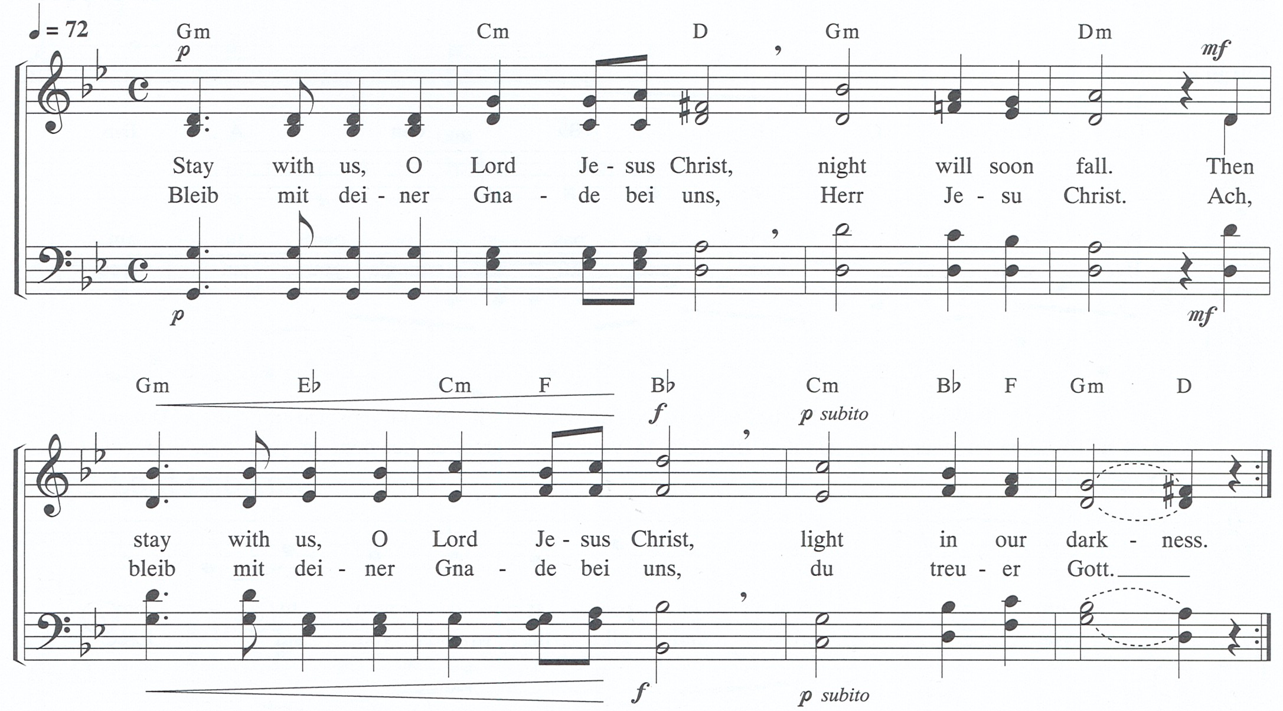

After Communion, the Celebrant says
Let us pray.

The people stand or kneel. BCP 366
People: Almighty and everliving God,
we thank you for feeding us with the spiritual food
of the most precious Body and Blood
of your Son our Savior Jesus Christ;
and for assuring us in these holy mysteries
that we are living members of the Body of Christ,
and heirs of your eternal kingdom.
And now, send us out to do the work you have given us to do,
to love and serve you as faithful witnesses of Christ our Savior.
To him, to you, and to the Holy Spirit,
be honor and glory, now and for ever. Amen.
The Celebrant says
Bow down before the Lord.
Celebrant and People
Look mercifully on this your family, Almighty God, that by your great goodness they may be governed and preserved evermore; through Christ our Lord. Amen.
Processional O love that casts out fear Hymnal 700
Dismissal
The Deacon dismisses the people, to which they reply: Thanks be to God.
Voluntary Allegro Alexandre Guilmant
Music at St. Paul’s
Join the Choir of St. Paul's for an English Cream Tea in the Parish Hall on Saturday, March 21 at 4:00 p.m. Enjoy tea, drinks (non-alcoholic beverages available), finger sandwiches and entertainment by the choir. Suggested donation of $20. Sign up in the Parish Hall, or email music@spechurch.com to reserve your spot. Proceeds help offset expenses for our residency at Wells Cathedral, U.K. in July.
ANNOUNCEMENTS
CHRISTIAN FORMATION

Sundays at 9:20 a.m.
Lenten conversations based on Tim Schenk’s Dust Bunnies In The Basket
March 15: Death by Chocolate - Kathryn Hedgepeth
Without being cliché, what do I give up or take on?
March 22: God’s Country - Cleve Callison
How do I use Lent to draw closer to God?
March 29: Prepare for Holy Week – The Rev. Ray Hanna
How do I draw my Lenten discipline together to prepare for a joyous Easter and beyond?

5 Wednesdays in Lent: Becoming Beloved Community – Healing the Wounds of Racism: Wednesdays beginning March 4, 5:45 – 7:30 p.m. Come share your story and hear others as we live into our call to heal. Sign up outside The Source for soup/salad/bread contributions. Nursery open and Meditative Art program for kids happening at the same time.
March 18: Repairing the Breach in Institutions and Society
March 25: Practicing the Way of Love in the Pattern of Jesus
April 1: Telling the Truth About Our Churches and Race
WOMEN'S READING GROUP: Monday, March 23, 9:30 a.m. in the Library. This month's book: Just Mercy, by Stevenson. Reading is not required, but our books lend themselves to questions and lively discussions related to our own lives experiences. St. Paul's women are invited to join us!
DREAMS / HELP HUB BOX LUNCH BENEFIT: Azalea Festival Weekend, April 3-4. Box lunches will be served during the Garden Tour. Help is needed with food and sandwich prep, runners, servers, bussers, and cleanup. Please contact Elaine Anlyan, Kathryn Hedgepeth, or Merrilie and Bob Crafts with questions. (Contact info is in the Directory).
HARRELSON CENTER TOUR, 20 North 4th Street, Tuesday, April 7, 11:00 a.m. The center hosts over 18 nonprofits that provide centralized humanitarian services to the Wilmington Community. St. Paul's supports Harrelson partners The Help Hub, Philippians3 Ministries and Family Promise. Sign up sheet available in the parish hall or email Merrilie Crafts merriliec@gmail.com.
BLESSING BAGS FOR THE HOMELESS: The St. Agnes Guild has started a Pilot Program for the homeless, providing a pair of socks, toothpaste and toothbrushes, chapstick, snacks and other provisions. Please take one from the Narthex or by the double red doors if you would like to help our homeless population. Any feedback would be appreciated.
EARLY BIRD BOOK STUDY: The group is discussing "The Way of Solomon: Finding Joy and Contentment in the Wisdom of Ecclesiastes" by Rami Shapiro. Meetings are Tuesdays, 7:30 a.m., in the Parish Library.
LENTEN REFLECTIONS 2020 – Salt and Light: A new reflection is being sent to email addresses each day. If you are not receiving Salt and Light each day, please contact the church office. Hard copies will be available at St. Paul's beginning Sunday, March 8.

WEEKLY CALENDAR
tuesday 3/17 tuesday study group library 7:30 am
morning prayer chapel 9:00 am
loblolly garden club parish hall 9:30 am
wilmington boys choir 6:00 pm
education for ministry library 6:30 pm
wednesday 3/18 staff 10:00 am
holy eucharist church 12:10 pm
community lunch parish hall 1:00 pm
lenten wednesday supper and program 5:45 pm
choir school 6:00 pm
spe choir 7:00 pm
thursday 3/19 gentlemen of noble poverty 8:30 am
morning prayer chapel 9:00 am
friday 3/20 men’sgroup parish hall 7:45 am
saturday 3/21 altar guild sacristy 9:00 am
cape fear knitters parish hall 9:30 am
st. paul’s choir tea parish hall 4:30 pm

Ministry Schedule | March 15 – The Third Sunday in Lent | March 22 – The Fourth Sunday in Lent
8:00 Greeter | Linda Collette | Tom Gerow
Lay Ministers | Steve Haughey | Spencer Weig
Breakfast Chefs | Larry & Merry Ann Wright | Bill Baker, Donny Cardwell
Altar Guild | Group 5 | Group 1
Bread Bakers | Valerie DeJarld | Cecelia Peers
Flower Guild | (Lent) | (Lent)
Greeters | Midge Silberman, Aimée Salinas | Tom & Sandra Ballard
Hospitality | Orange | Lavender
Intercessor | Mary Bridges | Kathryn Hedgepeth
Rug Shepherd | Keith Calder | Anne O’Dell
10:30  Lay Ministers | Cheryl Wagoner, Verger  Lectors: TBA, Ruth Gates,  Teresa Singer  EMs: Dot Erway, Steve Bucci  Communion Verger: TBA  Crucifer: Rachel Carroll  Gospel Book Bearer/Chalice: Carol Field  Paten: Cheryl Wagoner | Jeffrey Hughes, Verger  Lectors: Judy Farri, Cleve Callison, Sally Pope  EMs: Royster Hedgepeth, Sue Sramek  Communion Verger: Leon Tillery  Crucifer: Rachel Carroll  Gospel Book Bearer/Chalice: Don Brainard  Paten: Bill Anlyan
Ushers | Tom Hitchcock  Tom Matthews, Ron Morgan  Tom Trivett, Don Bobo | Bill Waterfield  Merrilie Crafts, Bob Crafts  Jane Harkness, Kenny Harkness
Vestry | Sally Pope | Keith Calder

Prayer List
In our parish… People requesting prayer
fr. john cawthorne joyce connelly herb gant david heath william murphy bill petry sally roberts jere lewis joann summey mack umphlett ralph tilden pat whitehead hilda robinson fred wilson | fr. john cawthorne herb gant david heath william murphy bill petry sally roberts jere lewis joann summey mack umphlett ralph tilden pat whitehead thelma adams ruthie grigsby hilda robinson fred wilson | fr. john cawthorne herb gant david heath william murphy bill petry sally roberts jere lewis joann summey mack umphlett ralph tilden pat whitehead thelma adams ruthie grigsby hilda robinson fred wilson
Please note that names will be removed after one month on the prayer list.
If you wish for continued prayer, please notify the office.

Celebrating March Birthdays
3/01 Donny Cardwell, 3/02 Larry Wright, 3/05 Livy Hitchcock,
3/06 Richard Rhoads, 3/07 Rocco Geisler, 3/08 Anne O’Dell,
3/09 Andrew Losee, 3/10 Susan Carter,
3/13 Marion Somersett, Bill Anlyan,
3/14 Azucena Aguilar, Eleanor Morton, Sherry Mulhollen
3/17 Louise Buck, Rachel King, Dianne Stansbury, Tom Trivett,
3/22 Pat Whitehead, Beth Van Amberg, 3/24 Tom Hitchcock, Rachel Bridges 3/27 Bill Baker, 3/29 Pat Baker, Bill Petry

A Warm Welcome to Everyone!
Thank you for worshiping with us today. If you are new to St. Paul’s, please fill out a Guest card and place it in the offering plate or give it to the greeter or an usher. We invite you to join us following the 8:00 a.m. Eucharist for breakfast in the parish hall. For those attending the 10:30 service, please stay for the reception also in the parish hall. Please come to St. Paul’s again.

Would you like to know more about St. Paul’s?
The first Sunday of each month, we host a coffee for all who would like to learn more about St. Paul’s Episcopal Church. Participation does not commit you to church membership, but it is an opportunity for you to explore the life and ministry of St. Paul’s. The coffee will be held in the library immediately after the 10:30 worship. Hope to see you there!

WORSHIP IN LENT
April 5 Palm Sunday
8:00 a.m. Holy Eucharist
9:00 a.m. breakfast
9:45 a.m. Liturgy of Palms. The gospel reading enacted by St.
Paul’s children
10:00 a.m. Procession of Palms - Route: Circumnavigate St. Paul’s/Andrews block. Bagpipes will lead the way.
April 8 Wednesday in Holy Week – Tenebrae at 6:00 p.m.
April 9 Maundy Thursday
6:00 p.m. Holy Eucharist and Stripping of the Altar
All-night Vigil in Chapel until 12 noon on Friday
April 10 Good Friday
12:00 noon Good Friday service
6:00 p.m. Stations of the Cross
7:30 p.m. The Crucifixion by John Stainer
Choir of St. Paul’s
April 11 Holy Saturday
8:00 p.m. Great Vigil of Easter
April 12 Easter Sunday
8:00 a.m. Holy Eucharist
8:45 a.m. Breakfast
10:30 a.m. Festal Holy Eucharist
Reception/Hunt for Alleluias & Eggs

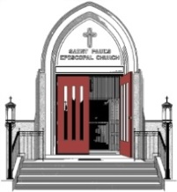
St. Paul’s Episcopal Church
16 North Sixteenth Street
Wilmington, North Carolina 28401
www.spechurch.com (910) 762-4578
Bulletin submissions: bulletin@spechurch.com (Deadline Mondays, 5:00 p.m.)
E-news submissions: e-news@spechurch.com (Deadline Mondays 5:00 p.m.)
The Rt. Rev. Robert Skirving, Bishop
The Rev. Raymond Hanna, Interim Rector
The Rev. Adam Pierce, Assistant Rector
The Rev. Richard Banks, Priest Associate
Ronnie D. Wise, Director of Music and Organist
Richard Rhoads, Assistant Director of Music and Organist
Carl Samet, Parish Administrator
Diane Matz-Kane, Finance Assistant
St. Paul’s Vestry

Keith Calder
Chris Coudriet
Joe Farri
Ruth Gates
Tom Gerow
Steve Haughey
Joan Rosko Miller
Sally Pope
Teresa Singer
Rhonda Stroud
Meaghan Thomas
Jan Vick

Treasurer: Judy Wilson
Clerk: Merry Ann Wright

